Assignment 3

Attempt to login
The first step is to attempt to login and look in the development console at the generated request. We can see that it’s sending a POST request at “index.php” with “Content-Type” “application/x-www-form-urlencoded”.
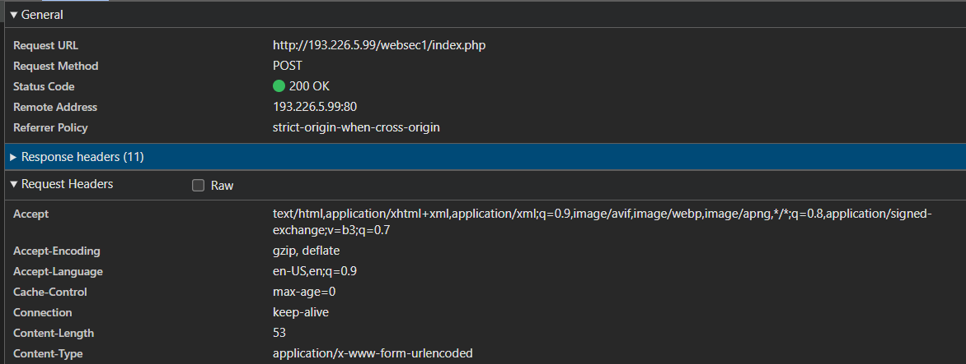

The exploit
To exploit this, we craft an html page that contains a form, which will do a POST request to http://193.226.5.99/websec1/index.php. In that request, we also encode some extra headers that will be sent with URL encoding, like: http://193.226.5.99/websec/index.php?hName=X-Frame-Options&hValue=ALLOWALL
